Lab - Guideline

Criteria to consider when choosing network media (from CISCO CCNA1).
What is the maximum distance that the media can successfully carry a signal?
Into what type of environment will the media be installed?
What is the amount of data and the speed at which it must be transmitted?
What is the cost of the media and installation?
www.submarinecablemap.com
A. FO
- Phenomenon: total internal reflection,
- Optical communication systems use high carrier frequencies (~ 100 THz) in the visible or near-infrared region of the electromagnetic spectrum.
- telecommunication applications: short-haul (intra-city, usually < 50km) and long-haul (inter-city)

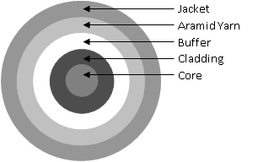
- multimode fiber
- 62.5/125μ or 50/125μ.
- 100Mbps -> 2000m; 1 Gbps up to 1000m;10Gbps up to 550 m
- loss: 1-2dB/km
- single-mode fiber
- 9/125μ
- up to 10 Gbps over 80 km (50 mi); DWDM: thousands of kilometers at 10 Gbps; hundred kilometers at 40 Gbps
- loss: 0,5dB/km
- optical transmitter
  - LED, LASER on different wavelength
- optical receiver
- photo-diodes
- junctions: mechanical and fusion, with loss of 0.5dB and 0.1dB
- connectors: SC and ST with loss of 1dB
- repeaters
- patch-panels
- budget of loss of optical link
- Testing
- power output
- bit error rate (BER) = average probability
of incorrect bit identification; values: 10⁻⁹ - 10⁻¹⁴
- OTDR Optical Time Domain Reflectometer
- optical amplification for increasing the repeater spacing and of wavelength-division multiplexing (WDM) for increasing the bit rate
- amplifiers spaced at 60-70 km apart
- Capacity:
- 40 and 100Gb Ethernet
- commercial WDM systems exceeded 1.6 Tb/s.
- commercial WDM operated by VSNL: 2.56 Tb/s (64 WDM channels at 10 Gb/s over 4 fiber pairs)
- world record: 1125 terabits per second, University College London (UCL)

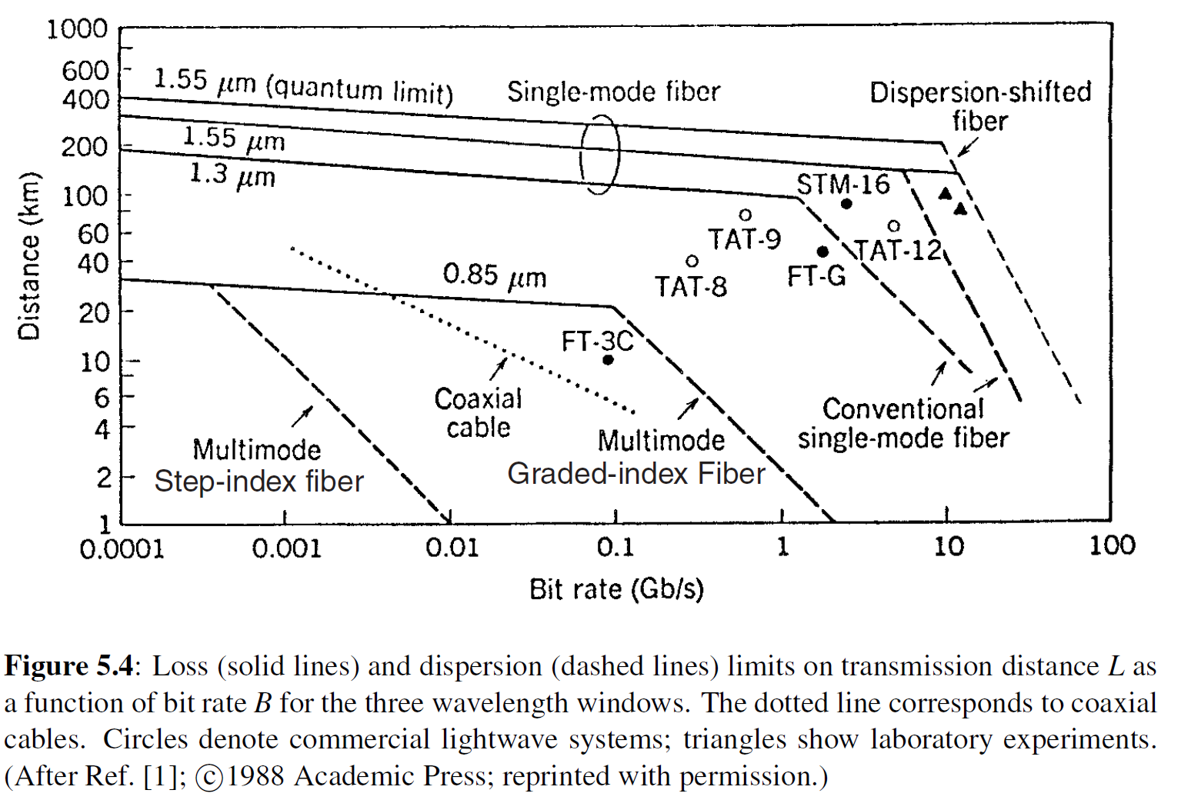
3.2 A 9/125μ single-mode optical fiber having the length of 2,5km and the loss equal to 0,5dB/km, which connects two DTE equipments is considered. The attenuation introduced by junctions and connectors is equal to 0,5 and 1dB respectively. The error margin taken into consideration is 3dB. The power of average emission of the transmitter is -15dB, the receiver sensitivity at a rate of errors given by BER 10⁻⁹ is -25dB and dynamic of the receiver is in the range -10 ÷ -30dB. Calculate the optical power budget.
Crt. | Optical loss or power | DB
1. | The km loss in Optical Fibre db/km X _____km fibre | _____dB
2. | The loss in Junctions ___dB/junction X _____junctions | _____dB
3. | The loss in Connectors __dB/connector X ___ connectors | _____dB
4. | Losses on other components | _____dB
5. | Margin of error | _____dB
6. | Total loss on the Link (1+2+3+4+5) | _____dB
7. | The power of average emission of the transmitter | _____dB
8. | Average power received by the receiver (7-6) | _____dB
9. | The dynamic of the receiver _____dB at _____dB
10. | Receiver sensitivity at a rate of errors given by BER | _____dB
11. | Available Remaining Power | _____dB

B. Structured Cabling

Hierarchical Network Design
Three-tier model:
- enterprise networks
- core layer: high-speed backbone layer between dispersed networks
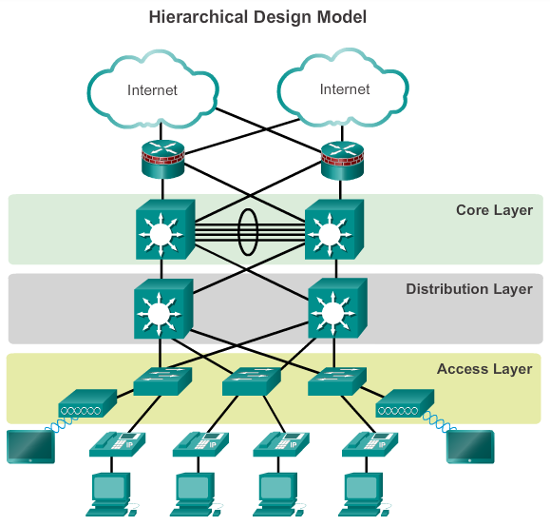

Two-tier model:
- smaller enterprise networks
- core and distribution layers are collapsed into one layer
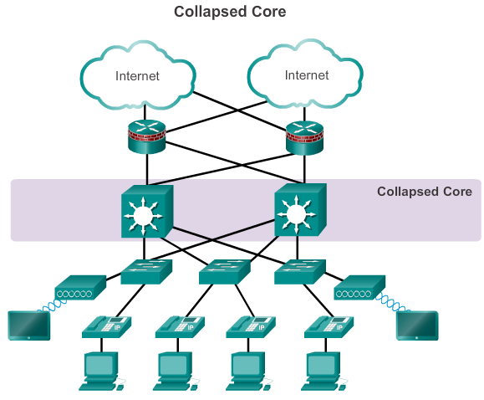

Cisco Enterprise Architecture
- core layer module-> high-speed interconnectivity between:
- distribution layer modules
- data center server farms
- the enterprise edge
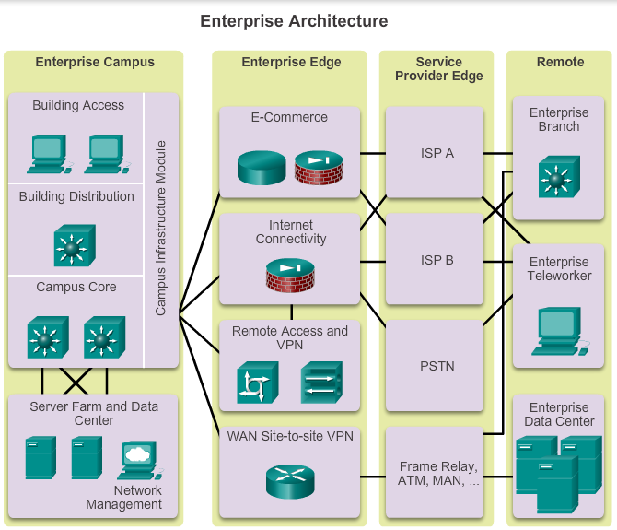
Choosing devices
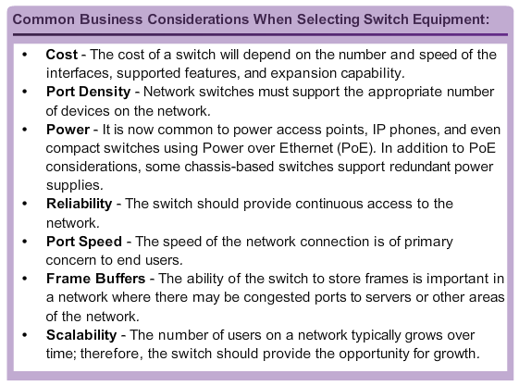
- Fixed Configuration Switches
- Modular Configuration Switches
- Stackable Configuration Switches: Cisco StackWise technology allows the interconnection of up to nine switches (fault tolerance and bandwidth availability)
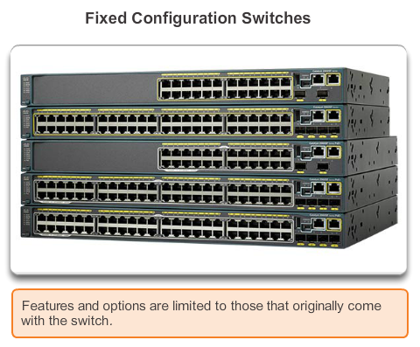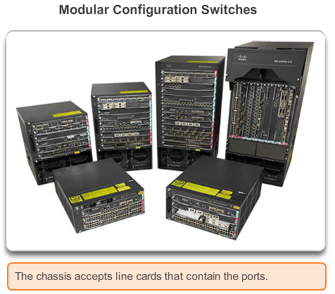
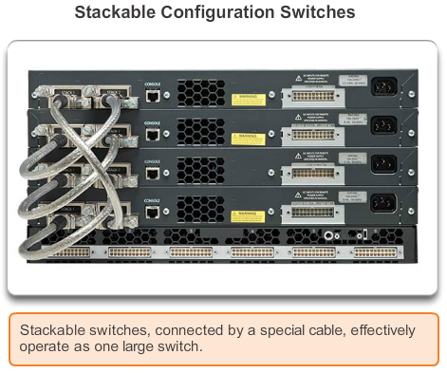
Switches:
- Layer 2 switch
- Layer 3 switch

- “form factor” switches
- modular switches

- Switching speed: millions of packets per second
- Backplane speed: how fast traffic can be transmitted between modules in a switch
- Buffer size
- Management and monitoring
http://www.enterprisenetworkingplanet.com/reports/index.php/28911/Enterprise+Ethernet+Switch+Buyers+Guide.htm

Example:
Cisco Enterprise: http://www.cisco.com/c/en/us/products/switches/index.html

